This task is based on Hurt Me Plenty task:

1. Create a user and give him permission to read-only mode for Jinkins jobs without the access to edit or change settings

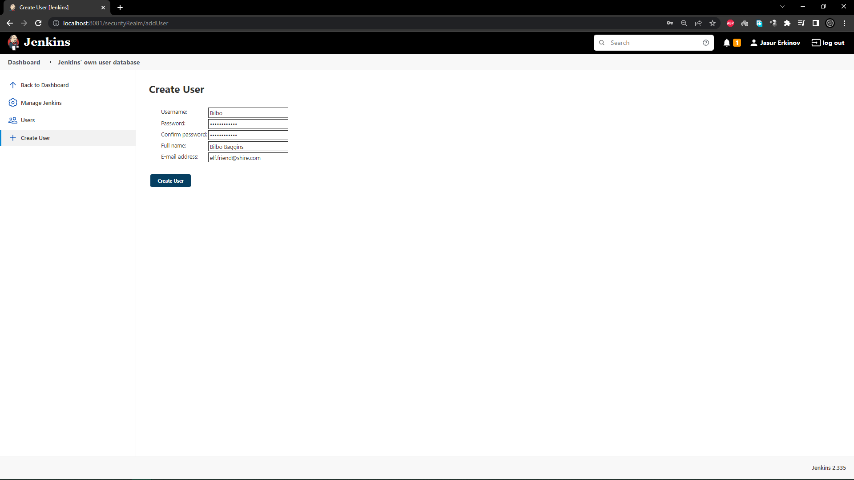

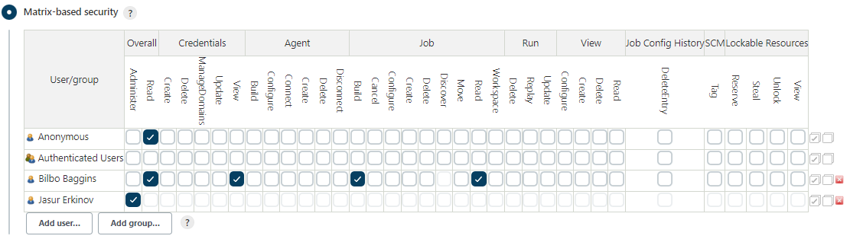

2. Create a parametrized job HelloUser which will ask for a user name as a parameter and output "Hello, username!" in the console

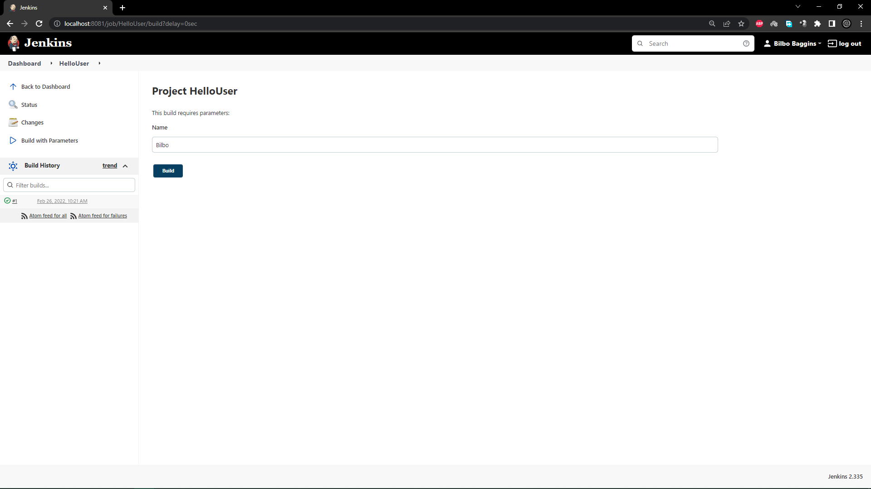

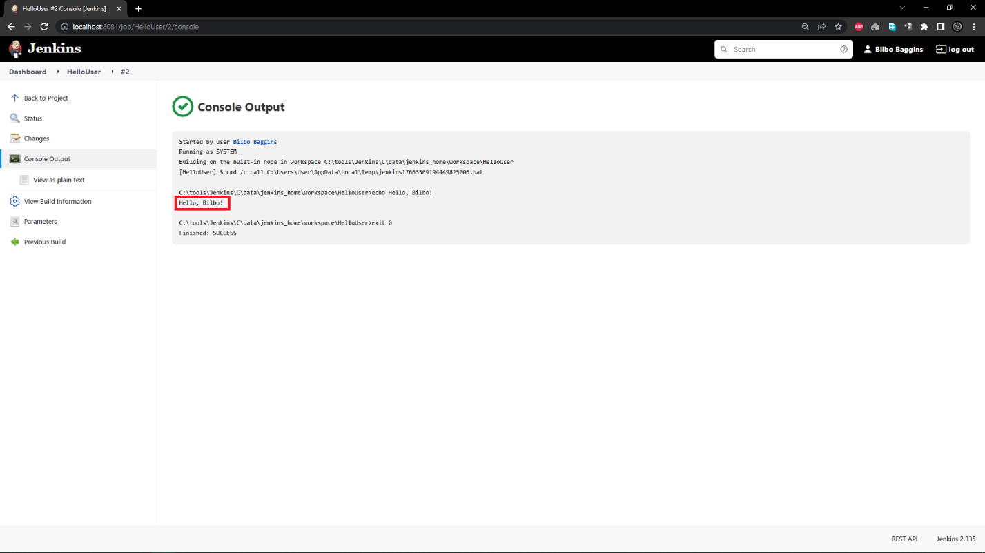

3. Mesure unit tests code coverage with the help of the goal  mvn cobertura:cobertura and publish it on the job page as a graphic

